

**Software requirement and specification**



**Use case diagram and use case scenarios**

Submitted to:

Dr. Amr Abo Hany

Submitted by: Salma EL-Sayed Borham

ID:17105510

**Use case diagram**

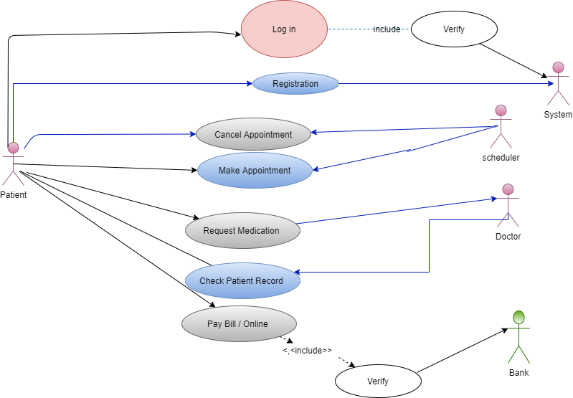

**Use case scenario**

|  |  |
| --- | --- |
| Use case name: Pay bill / online. | |
| Area: Clinic | |
| Actor(s): patient | |
| Description: allow patients to pay their bill through online payment | |
| Triggering Event: Patient uses Pay Bill Online web page, enters online payment credentials, and then clicks Complete Transaction Button | |
| Trigger type:  external  temporal | |
| Steps performed (main path) | **Information for steps** |
| 1- Patient logs onto secure Web server | **Username, Password** |
| 2- Patient’s user Profile is read, and password is verified | User profile, Username, Password |
| 3- Patient Select Pay bill / Online | User Profile |
| 4- Patient enters online payment Credentials on the pay bill online web form and clicks Complete Transaction button | Pay bill online Web Form |
| 5- Patient’s payment Credentials are verified | Pay bill online Web Form |
| 6- Patient’s profile is updated | Pay bill online Web Form |
| 7-Confirm web page is sent to the patient | Confirm page |
| Preconditions: patient on pay bill/online web page | |
| Postconditions: patient has successfully paid all medical bills | |
| Assumptions: patient has a browser, valid user account & online payment credentials | |
| Requirements met allow patient to pay bills online | |
| Outstanding issues: should the number of times the patient enters incorrect payment credentials | |
| Priority: High | |
| Risk: High | |

|  |  |
| --- | --- |
| Use case name: Make appointment | |
| Area: Clinic | |
| Actor(s): patient | |
| Description: allow patient to make an appointment | |
| Triggering Event: patient uses make appointment web page, enters an available date and time, then clicks Confirm button. | |
| Trigger type:  external  temporal | |
| Steps performed (main path) | **Information for steps** |
| 1-Patients logs onto secure web server | Username, password |
| 2-Patient’s user Profile is read, and password is verified. | User profile, Username, password |
| 3-Patient Select Make Appointment | User Profile |
| 4-Patients fills out the web form the make appointment web form then clicks Confirm button | Make Appointment web form |
| 5- Changes are validated on the secure web server | Make Appointment web form |
| 6-Patients profile and doctors’ timetable are updated | Make Appointment web form |
| 7-Confirmation web page is sent to the patient | Confirmation page |
| Preconditions: patient is on they make Appointment on the web page | |
| Postconditions: patient has successfully booked an appointment | |
| Assumptions: patient has a browser, and valid user account | |
| Requirements met allow patient to make an appointment using a secure web site | |
| Outstanding issues: should the number of times the patient login be controlled? | |
| Priority: medium | |
| Risk: medium | |

|  |  |
| --- | --- |
| Use case name: Cancel appointment | |
| Area: Clinic | |
| Actor(s): patient | |
| Description: allow patient to cancel any pending an appointment | |
| Triggering Event: patient enters username and password and uses cancel appointment web page, then clicks Confirm button. | |
| Trigger type:  external  temporal | |
| Steps performed (main path) | **Information for steps** |
| 1-Patients logs onto secure web server | Username, password |
| 2-Patient’s user Profile is read, and password is verified. | User profile, Username, password |
| 3-Patient Select Cancel Appointment | User Profile |
| 4-Patients fills out the web form the cancel appointment web form then clicks Confirm button | Cancel Appointment web form |
| 5- Changes are validated on the secure web server | Cancel Appointment web form |
| 6 -Patients profile and doctors’ timetable are updated | Cancel Appointment web form |
| 7-Confirmation web page is sent to the patient | Confirmation page |
| Preconditions: patient is on they Cancel Appointment on the web page | |
| Postconditions: patient has successfully Cancel an appointment | |
| Assumptions: patient has a browser, and valid user account | |
| Requirements met allow patient to Cancel an appointment using a secure web site | |
| Outstanding issues: should the number of times the patient cancels appointment be controlled? | |
| Priority: medium | |
| Risk: medium | |